**UKESF workshop improvements**

Original workshop: Earlston Highschool, 25th Oct 2017

Next, better, simpler, cooler, smoother workshop: somewhere sometime early 2018

**Agreed changes:**

* COMMON GROUND
* Shorten datasheets
* Ditch capacitors from voltage regulator
* Making instructions step by step + pictures
  + 1. Do the power wiring
  + 2. Wire up the LED strip + run a completed LED test code
  + 3. Wire up the Ultrasonic sensor + run a completed Ultrasonic sensor test code
  + 4. Complete the final code and run the whole system
* Explain the operation of the breadboard, using a pic like this:

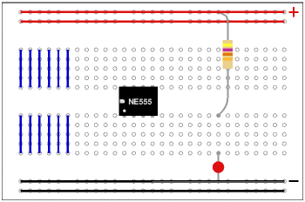

* Ditch the first two example codes, give only final code for them to complete
* Make the code more structured, simpler to understand
* Include Neopixel library into the USB sticks
* Laminate the master instruction sheet
* Update the presentation to tie in with the sheets more
  + Have text in the presentation so that it can be understood by anyone else (e.g. another teacher presenting)

**Other ideas**

* Two session thing ?
  + 1 – theory session, Arduino basics, breadboarding, simple code examples
  + 2- practical session, the actual Ultrasonic LED strip workshop
* Fancy power supply, with lights for ON, OVERLOAD etc.